TUBERMINATOR
  - First Page Video Ranking With FREE Tools And Resources
The main focus of this report is to show how to get involved in video marketing “on the run”, how to rank quickly on YouTube and Google using FREE (semi)-automatic tools and services. QUICKLY AND FREE. I will show methods and techniques I use to rank my videos, as well as free resources and tools to make video clips, to get backlinks and free traffic.
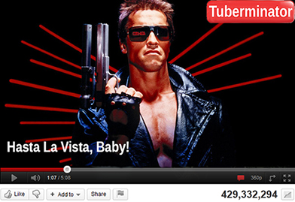

TABLE OF CONTENT

CREATING VIDEO________________________________________________________________Page 3

MAKING YOUTUBE ACCOUNT, VIDEO UPLODING, KEYWORD AND PAGE OPTIMIZATION______Page 9

INDEXING AND BOOKMARKING____________________________________________________Page 16

TRAFFIC _______________________________________________________________________Page 20

FREE RESOURCES________________________________________________________________Page 25

DISCLAIMER AND LEGAL NOTICES __________________________________________________Page 30

CREATING VIDEO

Two free video editing tools will be discussed: Windows Movie Maker Live software (which comes with Windows operating system or could be downloaded-updated for free) and an online video editing service from Animoto.com. Free Mac video editors will be reviewed too.

TOOLS

1/ Animoto.com

The editor does an excellent job in terms of video quality (for web purposes), themes, backgrounds, transitions and automates basically everything. You only need is to upload your images, type bullet points and choose music. The service has two options: free and paid. Here is the features comparison screenshot:

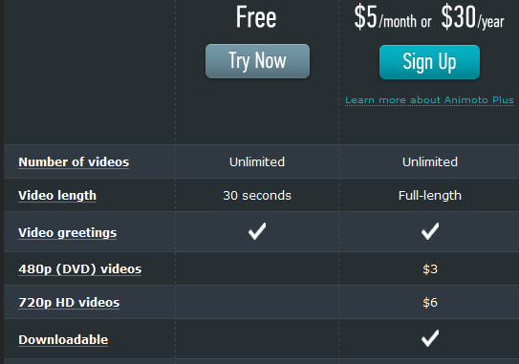

The main difference between the free and paid versions is a 30 second video length limit for the free plan. Therefore, if you are to use the free version you need to be concise in your presentation. Even though videos are not downloadable, you can upload the completed movie directly to YouTube.

After your clip has been uploaded to YouTube, you can download it using a Firefox extension called DownloadHelper. Optional: The next, paid version is $25/year ($30 - $5 coupon, Google for “animoto coupon”). This plan is probably ideal for most videos.

One of the disadvantages of these versions is the Animoto brand in the end. You can easily remove it using other video editors (you will find numerous YouTube 30 sec clips without Animoto brand) but be warned that it is against their Terms of Service. Upgrading to unbranded versions costs significantly more.

Animoto.com site has everything to start: features, sample videos, advanced plugins, resources and FAQs. Also, please find a tutorial in the bonus videos provided with this report.

PROS:
- Easy to learn
- Short production time
- Royalty-Free music library

CONS:
- Not a lot of customization
- 30 sec clip length
- Slide text limited to two lines
- No DVD or HD quality
- Animoto brand in the end of the clip

Here are two random Animoto clips from YouTube:

Free version
$25-$30/year version

Windows Users

2/ Windows Live Movie Maker

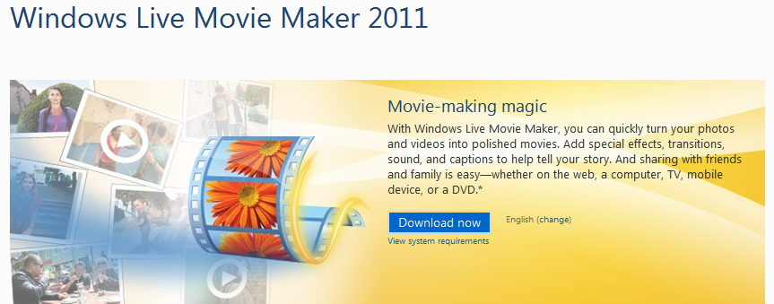

This free software is more than enough to start producing highly customizable videos. It takes some time to learn it though. Once comfortable, you can produce movies of excellent quality and any time length. Their website contains everything to get started. The program has more social media sharing options than Animoto and production includes a wide range of video output quality. The main disadvantage is that it does not have a royalty free music collection.

Please find a tutorial in the bonus videos provided with this report.

PROS:
- Highly customizable (compared to Animoto)
- Any video quality
- Come back and edit anytime
- No brand stamp

CONS:
- More time to learn (compared to Animoto)
- Longer to produce a clip (compared to Animoto)
- No music library

Optional: Additional list of free video editors is provided in the Free Resources section. One of the most popular and advanced video tools is Camtasia Studio which combines video editing with screen capture capabilities. This program requires a significant investment.

Some other paid video editors:

- CyberLink PowerDirector
- Corel Video Studio Pro
- Adobe Premier Elements (Mac version available)
- MAGIC Movie Edit Pro
- Roxio Creator
- VideoPad
- Pinnacle Studio HD
- Sony Vegas Movie Studio Platinum
- Roxio Video Lab
- ShowBiz DVD

Mac Users

2/ Apple iMovie

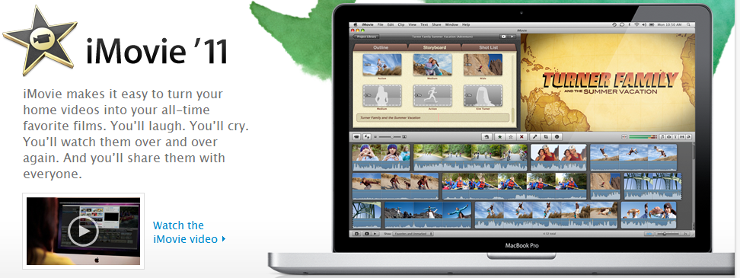

“Apple iMovie is comparable to Windows Movie Maker, but Apple iMovie is used on the MAC operating system. Apple iMovie has many advanced features and add-ons. The software is only free if you buy a new MAC system. If you want the software without buying the system, it is available for purchase. One of the best free video editor programs available for MAC users.”

Also see:

Best Free Video Editing Software for Mac

To summarize this section: Usually, video for marketing purposes does not require complex visual effects. There are plenty of free video editors out there. I mentioned the simplest and the best in my opinion. If you would like to spend more time to learn about other editors, please see the Free Resources section. Video training for Animoto and Movie Maker is provided on the corresponding homepages and in the video bonus tutorials coming with this report.

VIDEO CREATION

General Considerations:

You video should not be longer than an average song clip. Make it simple, with clear messages and call to action.

Four of many approaches to make a video are the following:

1/ Conservative

Similar to product sales pages, your clip could contain three parts:
- Point to the problem your product or service is going to solve
- Benefits (not features) of using namely this product or service
- (Optional: consider a short testimonial sample (social proof))
- Clear call to action

2/ Provocative-Entertaining-Emotional – laugh, shock, fear, humor, sadness, excitement, sex, money or anything eliciting an emotional response.

This one requires “out of box” thinking and could be hit or miss. The main goal is to entice viewers to click on your link. Up to your imagination.

3/ Instruction-Demonstration-HowTo

These videos are usually longer and more detailed. Google love them and they are often rank higher and included on Google top pages.

4/ Testimonials

These videos are usually used in addition to your main marketing video and represent live recording of a person who is using or have used the product.

Video Creation Techniques:

- Professional Video and/or Animation (expensive)
- Flash Video (Photo Flash Maker Free)
- Webcam and/or Video camera
- Cell Phone Video
- PowerPoint and/or Slideshow (Free software for making PowerPoint slides – OpenOffice)
- Video Compilation from existing sources
- Screen Capture
- Article to Video (ArticleVideoRobot – Free Trial)

Image and text sources for your video:

To find product or service related images the simplest ways are:
- Type your search term in Google Advanced Image Search and check the Commercial use box under Usage rights. Save the images you like (Paid option is to buy iStock images)
- Use Affiliate Resources Page of the product you are marketing
- Use a free screen capture tool such as Jing or (if you capture webpage images) Firefox web browser extensions (such as Pixlr Grabber). Also, see the Free Resources section and the bonus software coming with this report.

For text sources, go to the product website and grab information there or come up with your own headlines. In Animoto you are very limited with text space. Therefore, you need to be concise and stress out the most important points. In Movie Maker you can use images with the text captured from the product website or the affiliate resources pages.

If you make a short video it is a good idea to start with questions related to the problem followed by the main benefit points (answers to the questions) and finally a clear call to action (click on the link below, for example). If your clip is longer than 30 seconds, you have more options how to arrange your time-line.

You should watermark (include your website address, for example) your video. You can do it while making the video or later in YouTube using the annotation feature. If your movie is not watermarked you have done an excellent job for a potential video hijacker.

To summarize this section: Whether you are surprised or not, making videos is the easiest part. Regardless of how you arrange your time-line or presentation and whichever tool you use, the clip should not be longer than an average song (in order not to lose viewers’ attention) and should contain a clear call to action.

Note: Often, you can use already made videos provided on the affiliate page. You can also use review videos from authority sites. Similar to ezine articles, you just need to make sure you give credit to the source either in the video or in the description.

MAKING YOUTUBE ACCOUNT, VIDEO UPLODING, KEYWORD AND PAGE OPTIMIZATION

Keyword research

This is probably the most important step in your ranking strategy.

I am assuming here that you have a general knowledge of working with spreadsheets. If not please Google on how to use them. Download and install a free program called Open Office (or you might have Microsoft Office, which is a paid program, installed already).

General considerations:

Try to identify keywords with at least 1,000 searches per month and with less than 50,000 competitor pages for the “Phrase” option. If you go after these types of keywords it will greatly increase the chances to get your video on the first page of Google.

I would also like to address here the approach of finding so-called video retainer keywords. The idea is to type keyword candidates into Google and see if there are videos on pages 1-3 of the Google results. If videos are there then you are likely to rank your video on one of the first Google pages too. Conversely, if there are no videos then you should avoid such keywords.

Taking into account my own experience and the fact that Google’s algorithm always changes, my opinion is that it is often not the case. Therefore, while I agree that this is a valuable strategy I personally do not make it as one of the most important considerations.

Tip: Keywords starting with “how to” are very good candidates for ranking videos on Google.

Google Keyword Tool Research:

1/ First, I’ll describe a long approach.

You should know what you are promoting and have a general idea of the main keywords. If you have absolutely no idea what the main keywords are but at least have a website of the product or service you could do the following:

Go to Google Keyword tool and enter your website address there. The tool will give you a set of relevant keywords what it thinks that site is about. Export 50-100 most relevant keywords as a CSV (Comma-Separated-Value) file.

If you do have an idea of your main keywords or the affiliate program provides a set of keywords, paste them in the YouTube Keyword tool , choose “Descriptive word and phrases” and click “Get keyword ideas”. You’ll find that YouTube keyword tool will give you many results which are not relevant to your product or which have “Not enough data”. Choose those that are relevant (in most cases there will be very few) and have monthly search volume data and click “Add”. Then export added keywords as a CSV file. Combine them with your main keywords and paste into Google keyword tool. Now you have a set of keywords searched in Google and YouTube. Sort them by relevancy.

2/ Short approach.

Paste your keywords in Google keyword tool, search and sort by relevancy.

Now scan through the keywords and choose several candidates with relatively high search volume and relatively low competition value (usually they are long tail keywords – three or more word phrases). It is difficult to give recommendations on the exact search volume values since these are Google, not YouTube, numbers and they are very relative; but try to have broad local monthly searches more than a thousand and medium to low competition.

Go to YouTube, paste them one by one and see what your competition is. If you see videos with the exact keyword match in the title and hundreds of thousands views it will be hard to rank. If there are videos with a lot of views but no exact match in the title - it is a candidate. Based on these criteria choose your best keyword.

Note: If you are willing to spend money, such paid programs as Market Samurai and YouTube Spy will make these steps much easier.

YouTube account

First to note, you should have a separate YouTube (and email) account for every YouTube channel promoting similar products or services. If YouTube suspends one of your accounts, you will lose only a few videos, not all.

To make YouTube accounts you need to have email addresses.

For those of you who do not want to have Gmail accounts or feel comfortable with Phone Verification of a Gmail account please disregard the following paragraphs.

For those who have or would like to have many Gmail addresses: you probably know how difficult it is to create a Gmail account without phone verification (PVA).

If you do not want to be phone verified, here is a little trick to create Gmail addresses without PVA:

- Clear browser’s cookies (assumption is that you know how to do it or Google for it)
- Use unusual (or variations/misspelling of usual) First and Last names (you can change them later)
- Use random password
- Security Question – choose “Write my own question”
- Do not enter recovery email

You should not have problems with PVA.

To keep thing organized, it is a good idea to name each Gmail and YouTube account the same - with your main keyword. If, for example (let’s be original ), your main keyword is “dog training” then your Gmail and YouTube usernames could be, for instance, dogtraining647. The main point here is that your YouTube username should include your primary keyword.

(Optional) When your YouTube account is ready go to account settings and upload a photo. Fill out one or more of the sections (for example, interests) with keyword rich text.

Video uploading and page optimization

By now you have your primary keyword, YouTube account and video ready. Go to your video folder and rename your file to your main keyword. Upload the video to YouTube. Go to “Video Manager” and wait a few minutes until uploading and processing are completed and a video thumbnail shows an image. Click on “Edit info”.

Title

Each word in the title should start with a capital letter. The title should start (or at least include) with your primary keyword.

Often, you’ll find that marketers would have only their main keyword in the title, for example: Dog Training. Or two-three keywords arranged in a way like this: Dog Training | Dog Barking | Dog Biting. Maybe it works for them. It does not seem to be written for humans though and probably does not inspire people to click on such a title.

Criteria to be considered to optimize your title:
- Primary keyword
- Catchy title
- Asking a question
- Using power keywords such as discover, reveal, amazing, instant etc.

Description

Description should start with your link.

If you do not have your own website and have a long affiliate link, you should use URL shortening services like bit.ly. It shortens and cloaks the ugly looking link and, what is important, provides tracking data.

If you do have your own website or a squeeze page and would like to use the tracking features of bit.ly you can use a redirect script to your bit.ly link. It also provides an additional backlink to your site. Here is how to do it for html and php. (If you do not know what html and php mean, please Google for these terms.)

Your link should be followed by the primary keyword. Primary keyword is the beginning of your description body text. If you start your description text on the next line below the link, please keep in mind that the collapsed version of description can cover the text. Therefore, if you want the viewers to read your text, start it on the same line as the link.

You can use different sources for your description. Create it yourself, modify text from a website, copy-paste an original article or an article from article directories (keeping their links). Two-four paragraph text works fine for me. I try to enrich the text with related keywords, include a call to action followed by the link again and conclude with a title variation.

Description criteria:

- Start with the link
- Include your primary keyword in the beginning
- Depending on the text length and keyword density, consider having your primary keyword in the middle and in the end of the text body
- Add LSI (Latent Semantic Indexing = relevant, related) keywords
- If you used a copyrighted material and did not include your credits in the video, this is the place to include it
- Consider linking to an authority site in your description

Tags

The importance of tags is underestimated. Often, marketers simply do not bother to do research and optimize them. Some consider adding many tags as spamming YouTube. However, what you will find is that you can easily rank for them, sometimes even higher than for your primary keyword. Therefore, the more tags you add the better.

You should include here your primary keyword and its variations as well as the product author’s name. Separate tags either by comma or include each tag (one tag could consist of several words) in quotes.

If you have several videos for the same niche or product and want them to appear together in the related videos column, you should have your special tag(s) for all of them. Other tags could be different for each video to spread out your chances of ranking for different keywords. For example, if your product is an eBook “Dog Training” by John Smith, it comes from a website dogtraining.com, and you have several videos for this product, consider all your videos to include the following group of special tags:

dog training, dogtraning, dogtraining.com, john smith

Criteria for tags:

- Primary keyword
- Primary keyword variations
- Author’s name
- Product website address
- Special keywords (the same for different videos in the same niche/product)
- LSI keywords (different for different videos in the same niche/product)
- The more tags the better

Note: One interesting technique to generate/hijack traffic is the following. Find your competitor with lots of traffic/views. Copy his/her tags (and title); add them to your tags. Whenever his/her video is watched your clip will be in the related videos column.

Category

If you want targeted visitors – then choose the corresponding category. If your video is general and you want more traffic use common sense. For example, Entertainment, Music, Film and Animation would have more traffic than Science. Many affiliate products answer “how to” questions and correspondingly should go to Howto & Style.

Video Thumbnail

It is important to have an attractive thumbnail, not just image of text or background. While some marketers believe that YouTube picks thumbnails at 1/3, ½, 2/3, and others – ¼, ½, ¾ of the video time-line, I have found that it actually fluctuates around those points and random.

Therefore, if you use Animoto there is not much you can do. With Movie Maker you can edit the original video source by inserting an image you want as a thumbnail and extending its exposure time around the time points mentioned above. Then you re-upload the edited version. All this takes time. In any case: you have a choice of three thumbnails you can use as your main one.

Tip: If your content allows, insert a good looking woman image around those points.

Broadcast and sharing options

Privacy – Public
License – Standard

Comments

Comments are a very important criterion which YouTube uses to evaluate how popular videos are. You can automatically allow comments.

However, it could also be used by competitors to kill your video. My understanding is that there are special words such as “scam” etc. which mark your video for a review. Since YouTube wants viewers to have positive experience, if this happens you immediately get a 6-months warning. If video turns out to be a copyrighted material your account can get suspended.

Therefore, if you really want to control this feature consider setting it to “Allow all comments with approval only”.

Comment Voting

This could be used by others to manipulate your comments. But until you reach high view count it is probably not that much of importance. You can leave the default “Yes” here.

Video Responses

Allow responses for the main reason that these are additional backlinks to your video.

Ratings – Yes, allow this video to be rated by others.
Embedding - Yes, external sites may embed and play this video. Make sure your video is watermarked.
Syndication - Yes, make this video available on mobile phones and TV.

AudioSwap

If your video does not have an audio track, this is the place to add your music.

Annotations

This is a great feature. You can use it in many ways: to direct viewers to what you want them to do, call to action, watermark the clip etc. But what is important is that annotations are text and could be crawled by Google. Use it to add at least your primary keyword.

One approach to add keywords is to minimize the text size and the time your annotation is displayed.

You can also make your text clickable to link to another YouTube video, playlist or channel.

Keep in mind though that those links are only internal for YouTube website properties. If you want to make a clickable overlay to an external link - use this method.

Captions and Subtitles

This feature is designed for people with hearing problems. You can experiment here with your ideas.

Edit your video

If you want to do quick fixes, apply photo effects or experiment with music content you can do it here.

Your YouTube Channel

As mentioned earlier, if it is not your primary channel and you want to do minimal amount of work but have it at least somewhat optimized – add a photo and insert a keyword rich text in your profile.

When you have several/many videos uploaded, improve your channel optimization and design (for example, background) to encourage visitors to subscribe to your videos and channel.

Flagging

Flagging is a process of users complaining-informing YouTube that your videos are in breach of community guidelines. The result is receiving one or more warnings and depending on Youtube’s decision – potentially permanent deletion of your account. There are many factors which could influence flagging.

Duplicate content and your competitors are some of them. There is no appeal process and as sad as it sounds there is not much you can do about it. My recommendation is always backup your videos and spread them among different YouTube accounts. Make sure you are familiar with YouTube community guidelines:

http://www.youtube.com/t/community_guidelines

INDEXING AND BOOKMARKING

While there are many ways to index and bookmark a YouTube video, I will only focus on free, easy, quick and (semi)-automated resources.

After you uploaded your video go to bulkping.com

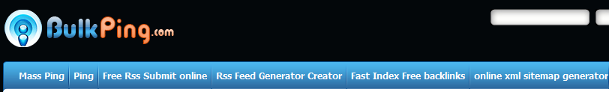

Make a RSS feed (RSS Feed Generator Creator)

Submit your RSS feed (Free RSS Submit online, make sure to validate it).

It submits your link to 27 RSS directories and helps quickly index your video.

Optional: Use “Fast Index Free Backlinks” feature. It submits your URL to about 2500 statistical sites. While, as of today, only about 300 of them work and Google does not seem to count many of them, it helps. Also, keep in mind it takes more than 60 minutes to complete the task.

Go to onlywire.com



Sign up for an account. Download the program. Create social accounts (optional: hire somebody on fiverr.com for $5 to create accounts for you).

Onlywire automatically submits your URL to more than 50 bookmarking sites. Allowed limit for a free account is 300 submissions per month. While less than fifty work and you have to enter 4-5 captchas manually it is free and automatic.

If you use more than 300 submissions in less than 30 days your account will be suspended. You will create a new free account.

Go to imautomator.com



Create an account. Start submitting. With a free account you are allowed to 10 submissions per day. Most of the sites are different from onlywire.com. IMAutomator have their own accounts so that you do not have sign up for each of them. You have a choice of drip-feed submission in 1, 15, 45 days. About 10 out of 15 submissions work.

Go to socialmonkee.com



Create an account. Get 25 unique inbound links every single day – free. Download and install socialmonkee Firefox plugin. Social Monkee allows spintax. With paid versions you can submit up to 125 sites with drip-feed feature. Leave a comment on their site with your URL for an additional backlink.

Go to 247backlinks.info and 247Backlinks.com



Sign up and get 1,000 free scheduled backlinks. You are allowed a maximum of 25 projects at any given time. Also, you will receive 1,000 backlinks for every new person you introduce to this website. On top of that, you will receive 10% of the backlinks for every purchase your referrals make (cookies last for 1 year).

If you are willing to pay 0.001 cent/link you can get up to 100,000 backlinks. They also provide summary reports. Their fresh and constantly updating database contains in total more than 33 million URLs, including more than 4,000 forums and more than 1,000,000 blogs. Their support team will actually reply to your emails.

Go to contentbuzz.com



Create an account, download software, and start using your free 200 credits. Contentbuzz (used to be videowildfire.com) is a private network of members promoting each other’s content. They have bookmarking and video promotion services. Free account does not allow much of submitting to video sites, but you can use the service for bookmarking. Many sites are different from onlywire and imautomator. Free and automated.

Go to Tubemogul.com



This service is a free online video submitter for non-commercial videos. You can try to submit your video to video sharing sites here for free. However, keep in mind that if they consider your videos to have commercial intent your videos will be deleted.

Other video submission sites and notes

You will find many video submission sites in the Resources section. Submission is free but you have to go there, create accounts, and submit videos – one by one.

YouTube has its own “Share” button. You can use it too. However, all their services are covered by the above bookmarking submitters.

Do not forget to use Youtube’s email button to email your video to as many addresses as possible.

Similarly, use your channels “Post a bulletin” function to broadcast your newly uploaded video.

Use your other YouTube accounts to rate, view, subscribe, add to playlists, like and comment on your new video.

Send friend requests regularly to other members to increase your visitor counts and other statistics.

Comment on related videos and post video responses. Since your YouTube/channel’s username is your primary keyword you get an anchored backlink from a related YouTube page. This is a great approach for getting powerful backlinks to your videos and it increases your chances to appear at the top of Google.

Embed your video to your blogs and other web properties. Make video sitemaps (for HTML - VideoSiteMapPro, for wordpress – use one of these plugins) and submit them to Google.

TRAFFIC

If you did proper keyword research and video page optimization, by now you should see your video on the first page of YouTube (and hopefully Google) for your primary keyword or for one of the tags. You should also start to see some organic views.

The number of views help people click on your video, and the more clicks/views you have the higher your ranking. The higher your rankings the more views you get. Together with increasing number of social bookmarks it is sort of a snowball effect.

YouTube ranking depends on the following criteria, in this order:
1) Views
2) Subscribers
3) Favorites
4) Likes
5) Comments

Additional Criteria:
- Video title
- Description
- Tags
- Number of incoming links
- Number of shares
- Age of video
- Number of playlist additions
- Flagging
- Number of embeds
- Channel views
- Number and quality of sites that host or point to your video

However, it is a combination of all of the above as well as your keyword research, backlinks and page optimization. Also, there is a lag on YouTube and sometime it takes more than a week to get to the first page.

To help with your view count, there are free view exchange programs. There are many of them. The main idea is that you automatically watch videos of the network members and earn credits. In turn, you submit your video’s URL and get views from other participants.

Among those programs, in my opinion, the best one is Vagex.com



You do not only get views but subscribers, favorites, likes and comments too. It does not violate YouTube TOS, randomized, and you get everything in correct proportions: the number of comments is smaller than likes, likes smaller than favorites etc.

The way it works is you download and install their program. They also have a Firefox plugin. You are allowed up to five IPs (IP – internet protocol) and five machines per IP (if you do not know what IP is please Google for it). The system is very flexible: you can stop, edit, add and delete your task any time.

If you decide to use it and you do not want to hear the sound of playing clips there are two ways to mute it. One is to drag the volume slider on the YouTube video all the way down, as opposed to pressing the mute button. This will effectively silence all YouTube videos. If it does not work, you can mute the whole Firefox browser: click on the sound icon in the task bar, choose mixer and mute Firefox.

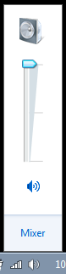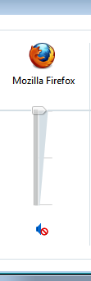

System also allows to earn money if you watch clips and do not submit your videos.

When you have just submitted your video and start running the task it gives about 150 views per day. You can earn credits not only by watching videos but also by submitting Vagex links to Facebook, Twitter, forums etc.

In combination with other similar view exchange tools (see below) you can get a huge amount of views very quickly which definitely helps your rankings.

A few other view exchange sites:

http://www.hitsincreaser.com/
http://viewet.com/
http://u2bviews.com/
http://www.enhanceviews.net/
http://www.subxcess.com/
http://socialmedianetworkexchange.com/

Disclaimer: You will find that some of these sites are on the border of YouTube TOS. It is up to you to decide whether to use them or not. Other more advanced and/or more grey-hat methods and techniques are not mentioned here.

Additional Resource:

You can download free trial of TubeToolbox and use its awesome features for free.

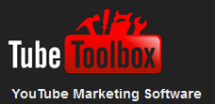

Other ways to increase view counts and traffic to your videos:

- Set autoplay on your YouTube channel:

  - Sign in and go to “My Channel”
  - Click on “Videos and Playlists”
  - Check “Autoplay featured video” and save changes

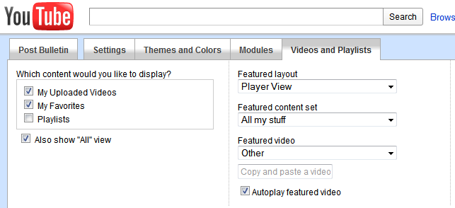

- Add as many friends as you can. For instance, search your niche. You’ll see videos and owners usernames. Send them “friend invitation”
- Send your videos to your friends
- Add video responses to videos in your niche with high view count and high rankings
- Comment (do not spam) videos in your niche with high view count and high rankings
- Use annotation feature to insert links to your other videos
- Use other YouTube accounts to promote your main video
- Get as many friends and followers on Facebook and Twitter as possible and promote your videos

Other popular free video marketing methods:

- Send messages to your Facebook friends
- Tweet on Twitter
- Post on Forums
- Comment on related blogs
- Post on your other web properties.
- Embed videos to your web properties. Make video sitemaps and submit them to Google.

To summarize this section: A lot of videos on YouTube with high view count contain non-organic views. There are many ways to do it. The tools shown here comply with YouTube TOS, free and automated. They will definitely help you rankings.

Next steps

Reaching high rankings is not the end. You need to stay there. You could hope that your videos go viral but this is not always the case. Therefore, you need to work on backlinking. But this is beyond the scope of this report.

While talking about viral approach to video marketing, I would like to mention VideoForward.com



This is however a paid membership site. What you can do there is create a separate video page for your videos or any video including, for example, YouTube most viewed clips. To monetize it you can then put Adsense, Affiliate or CPA offers as well as an opt-in form around the video. Additional way to make money is when visitors come to your page and then join the program. You do not have to create a separate website and you can have as many video pages as you wish.

In conclusion, I would like to say that obviously there are better ways, tools and methods if you invest money. But if you want to get involved in YouTube and video marketing with no initial investment, I hope this report provides enough free and (semi)-automated tools and resources for you to get started and quickly get your videos ranked on YouTube and Google. The only thing left is to take action.

Good luck!

FREE RESOURCES

This is a collection of free or free trial YouTube related tools and resources I found on the internet.
Disclaimer: I am not affiliated with them and have not tried each one of them, no recommendations are made and I am not responsible for any issues you may have.

YouTube Friend Adder Elite – Free Trial

Here Are Some Of The Features:
* Manage Multiple YouTube Accounts
* Gather Video ID's From Pages
* Send Multiple Friend Requests
* Send Multiple Messages
* Send Multiple Comments
* Multiple Settings and Decaptcher Capabilities
http://www.friendadderelite.com/youtube-friend-adder-elite.html

YouTube Opportunity Finder – Free Trial

YouTube Opportunity Finder Features:
Easily find videos sorted by views using the built in searcher
Save statistics to your hard drive, so you don’t accidentally contact the same video owner twice (especially ones that have multiple videos)
Ability to create customized messages to different users with the built in ‘message spinner’
Ability to auto-fill the user message within YouTube, so you don’t have to manually type in messages to each individual YouTube user
Supports automatic form field filling (i.e., “%username%” and “%videoname%” to automatically replace certain variables)
http://www.affiliateinabox.com/youtube-opportunity-finder/

TubeAdder – Free Trial

TubeAdder is an innovative YouTube software program that allows you to send friend requests to hundreds of members of the YouTube community and also makes it possible for you to leave comments on as many videos as you want – all within a matter of minutes!
http://www.tubeadder.com/

Free YouTube Uploader
Main Features
Multiple videos uploading.
Multiple YouTube accounts.
Various upload methods: Open file dialog, Drag & Drop, Right click etc.
Auto Upload Assistant: A smart plug-in that integrates with every video player (Windows Media Player, VLC, BSPlayer etc.) and lets you upload your video directly to your account.
Upload Scheduler: select a video (or several videos), set the time, and the scheduler will start the uploading process automatically.
Share your videos with your YouTube friends or with your email contacts.
Send your videos directly to your Twitter account.
Create and manage playlists easily
http://www.shacksoftware.com/

Free YouTube related and video tools and software

http://dvdvideosoft.com/

Embed YouTube Video – Free Edition

Features:
Add YouTube, Google Video, Metacafe, Vimeo, MySpace videos
Mac and Windows Versions
Automatic thumbnail creation
Adding caption
Rounded corners of overlay window
A lot of nice gallery themes
Built-in FTP
http://www.embedyoutubevideo.com/

YouTube Bulk Uploader

Features:
Upload unlimited number of videos
Account rotation
Filename, random keywords and {Word1|Word2|…} system to create automatic an individual description for each video.
Url list to the videos after the upload
Using of Bit.ly for links
Check if your accounts and videos are still alive!
http://botmaker.info/youtube-bulk-uploader/

Free YouTube Clone Script

Make Your Own YouTube Like Site
http://www.freewarebb.com/files/file/9496-free-youtube-clone-script-12/
click “Download”, on the next page click “Download (Other Versions)”

YouTube Helper Tool

This software allows you to make friends on YouTube. It's the perfect marketing tool for those who wish to reach out to millions of users on YouTube. The demo version disables certain functions and comes with Google ads. It does not support multiple users in the database, which is available on the full version only.
http://www.icdotnet.com/

Screencast-O-Matic

Screencast-O-Matic is the original online screen recorder for one-click recording from your browser on Windows, Mac, or Linux with no install for FREE!
http://www.screencast-o-matic.com/

30 Video Editing Software And Online Tools

http://www.hongkiat.com/blog/video-editing-30-free-tools-and-web-services-to-get-things-done/

29 Top Video Submission Sites + 5 Free Video Creation Tools and More

http://getinternetmarketingstrategies.com/2010/08/29-top-video-submission-sites-5-free-video-creation-tools-and-more/

Comparing 12 Free Screencasting Tools

http://www.emergingedtech.com/2010/01/comparing-12-free-screencasting-tools/

YouTube Intromaker

You type away on the keyboard and the software records it to a video for you.
http://amigacam.net/blogs/blog1.php/2011/08/15/ytintromaker

Vreveal

With vReveal 3, you can easily stabilize, brighten, and sharpen your videos, for free. Manage all your clips; create amazing panoramas, plus much more.
http://www.vreveal.com/download

Top 5 Free Video Editor Review

http://www.best-video-editor.com/resource/top-5-free-video-editor-review.html

Best Free Video Editors

http://www.techsupportalert.com/best-free-video-editor.htm

Best Free Video Editing Software for Mac

http://www.alifesoft.com/blog/2011/2/20110211128316.html

Comparison of video editing software (see “List Price” $0.00)

http://en.wikipedia.org/wiki/Comparison_of_video_editing_software

Free Video Editing Software

http://download.cnet.com/windows/video-editing-software/?tag=mncol%3Bsort&filter=licenseName%3D%22Free%22|&filterName=licenseName%3DFree|&rpp=30&sort=

YouTube downloaders

There are a lot of free downloaders and web browsers’ extensions on the internet. Just do a Google search. If you use Firefox, one of the extensions is YouTube DownloadHelper.

Free Firefox social bookmark-related extensions:

Shareaholic
ShareThis
Video Bookmarks
AddThis
Delicious Bookmarks
Delicious Post
Google Bookmarks for Firefox
HootBar
Instaright - social bookmarks (Instapaper)
Linkedln Companion for Firefox
Pearltrees
PickMe Web – Online Social Bookmarking
Socialite
Yoono
Bookmarker
Scuttle
Deng Google Bookmarks
Folkd
OYAX Companion
Jet Donkey Social Bookmark
7Live7 Bookmarks
BibSonomy
Bookmark on Utopic
Mister Wong Toolbar
Socializer! For Firefox
MultiSocialSidebar
QQBookmark
SocialMediaShares
Socialize extension for Firefox
Go Social
Sale forever Toolbar – Social Network – Gutscheine
Booknshare Orange Button

DISCLAIMER AND LEGAL NOTICES
The information presented herein represents the view of the author as of the date of publication. Because of the rate with which conditions change, the author reserves the right to alter and update her opinion based on the new conditions. The report is for informational purposes only. While every attempt has been made to verify the information provided in this report, neither the author nor his affiliates or partners assume any responsibility for errors, inaccuracies or omissions. Any slights of people or organizations are unintentional. You should be aware of any laws which govern business transactions or other business practices in your country and state. Any reference to any person or business whether living or dead is purely coincidental. The Purchaser or Reader of this publication assumes responsibility for the use of these materials and information. Adherence to all applicable laws and regulations, federal, state, and local, governing professional licensing, business practices, advertising, and all other aspects of doing business in the United States or any other jurisdiction is the sole responsibility of the Purchaser or Reader. The Author and Publisher assume no responsibility or liability whatsoever on the behalf of any Purchaser or Reader of these materials.

